Complex Sentence

✅ Definition:
# Source: Chatgpt (GPT-4-turbo) at [7/29/2025]
A complex sentence contains:
- One independent clause (main idea)
- One or more dependent clauses (subordinate idea)
The dependent clause cannot stand alone, and it is often introduced by a subordinating conjunction or a relative pronoun.

🔗 Common Subordinating Conjunctions:
# Source: Chatgpt (GPT-4-turbo) at [7/29/2025]
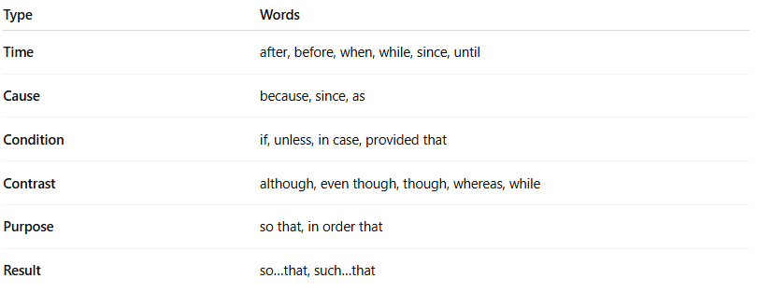
Type | Words
Time | after, before, when, while, since, until
Cause | because, since, as
Condition | if, unless, in case, provided that
Contrast | although, even though, though, whereas, while
Purpose | so that, in order that
Result | so…that, such…that

🧩 Structure:
# Source: Chatgpt (GPT-4-turbo) at [7/29/2025]
[Subordinating Conjunction + Dependent Clause] + , + Independent Clause
OR
Independent Clause + [Subordinating Conjunction + Dependent Clause]
✅ A comma is needed only if the dependent clause comes first.

✏️ Examples of Complex Sentences:
# Source: Chatgpt (GPT-4-turbo) at [7/29/2025]
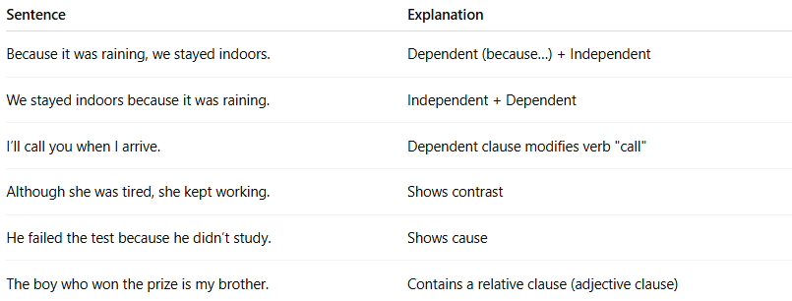
Sentence | Explanation
Because it was raining, we stayed indoors. | Dependent (because…) + Independent
We stayed indoors because it was raining. | Independent + Dependent
I’ll call you when I arrive. | Dependent clause modifies verb "call"
Although she was tired, she kept working. | Shows contrast
He failed the test because he didn’t study. | Shows cause
The boy who won the prize is my brother. | Contains a relative clause (adjective clause)

📌 Key Features:
# Source: Chatgpt (GPT-4-turbo) at [7/29/2025]
- Only one main (independent) clause
- At least one subordinate (dependent) clause
- Often uses subordinating conjunctions or relative pronouns (who, which, that)

🧠 Quick Check: Complex or Not?
# Source: Chatgpt (GPT-4-turbo) at [7/29/2025]
- While I was cooking, the phone rang. ✅
- She dances and sings well. ❌ (Simple)
- He didn’t study, so he failed. ❌ (Compound)
- I know a place where we can rest. ✅

